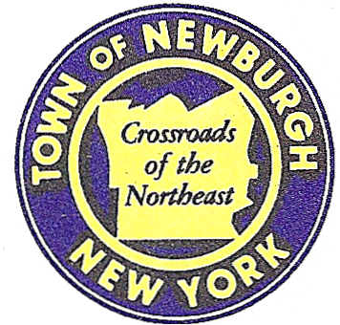

TOWN OF NEWBURGH
_______Crossroads of the Northeast __________________________
OLD TOWN HALL
308 GARDNERTOWN ROAD NEWBURGH, NEW YORK 12550

PLANNING BOARD
JOHN P. EWASUTYN, CHAIRMAN
TELEPHONE 845-564-7804
FAX 845-564-7802
E-MAIL: planningboard@townofnewburgh.org

PLANNING BOARD AGENDA

July 7th, 2016

*PLEASE NOTE: The Planning Board Meeting will start at 7:00 P.M. and all Applicants/Representatives
are to be present at that time. The Meeting will be held in the Meeting Room of Town Hall,
located at 1496 Route 300, Newburgh NY.*

1. Colandrea Sunshine Ford Lincoln (2015-24) AMENDED SITE PLAN
40 Route 17K
Section 99, Block 4, Lot 23.2 & Lot 1 (formerly)
Section 99, Block 1, Lot 17.2 (formerly)
Zone: IB
Rep: Shaw Engineering
81 Balmville Road
Newburgh, NY 12550

2. Dixon Subdivision II (2014-15) AMENDED SUBDIVISION
85 Forest Road
Section 3, Block 1, Lot 103.31
Zone: AR
Rep: Talcott Engineering
1 Gardnertown Road
Newburgh, NY 12550

3. Mid Valley Properties Site Plan (2016-10) INITIAL APPEARANCE
283 North Plank Road SITE PLAN
Section 34, Block 2, Lot 52 & 53
Zone: IB
Rep: Talcott Engineering
1 Gardnertown Rd.
Newbugh, NY 12550

4. Golden Vista (99-33) PUBLIC HEARING
(Meadow Hill Expansion) AMENDED SITE PLAN
Section 60, Block 1, Lot 9.1
Zone: R-3
Rep: John Meyer Consulting
120 Bedford Rd.
Armonk, NY 10504

*WORK SESSION*
Project Readiness Discussion scheduled for 5:00 p.m. in the Meeting Room of
Town Hall on Thursday, July 7th, 2016.*

